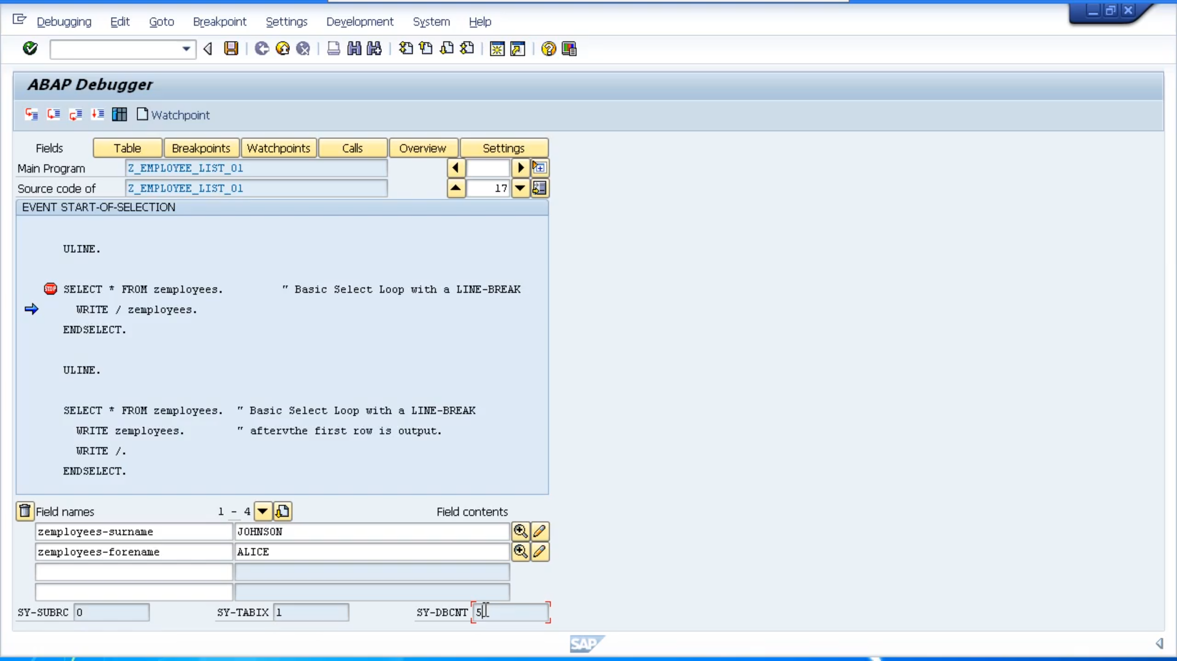Now you'll also see at the bottom of the screen. We have three fields, SY-SUBRC, SY-TAPIX, and SY-DBCNT.

And you'll note that the actual value boxes are grey down. Which means we can't change the values of these fields ourself. These fields are system fields, and actually belong to a table called SYST.

This system table actually contains a whole lot more system fields that get filled in at runtime. These system fields are updated automatically while your program is executing.

Most statements within ABAP cause the system fields to be filled with zero when they are executed successfully. But it's important to remember that these fields are completely statement dependant, meaning that they will contain different values, depending on which statement is executed.